Birkenfeld, 22 October 2019

Surface finish gives special style

Unusual cutlery surfaces are still very much in vogue. proHeq meets this enduring desire for individuality by offering both a range of finishes and rapid availability. WMF Professional and HEPP now have various PVD models permanently in stock. Hoteliers and restaurateurs can also create their very own personal fine dining atmosphere from an attractive range of design options. In addition to PVD coating and classic silver plating, WMF Professional and HEPP use three other processes for exclusive finishing of stainless steel products: stone washing gives the cutlery a striking vintage character, while glass bead blasting adds a silky matt shimmer and brushed models enchant with their elegant satin finish and dynamic look. In addition, cross finishing provides particularly exquisite accents, combining the various finishing processes.

WMF collections
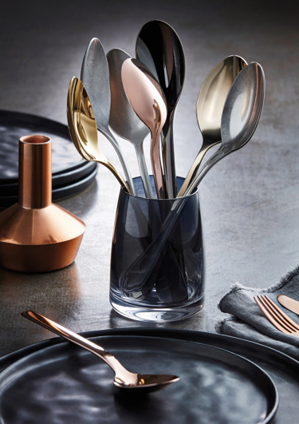
PVD coating meets the demand for various colour tones, with a choice of copper, gold, anthracite and light gold, making each cutlery model an individual companion on the set table. WMF Professional now offers a total of seven models in various PVD variants as well as a striking stone washed look, directly from stock: With clear lines, the SIGNUM cutlery collection is available in radiant gold; the colour provides an exciting contrast to the simple style. The clear, functional forms and geometric lines of the UNIC model are in harmony with the copper PVD version. Both options are held in stock, as is the festive JUWEL cutlery series in light gold. This composition makes the elaborate bevelling at the end of the handle seem even more sophisticated. In contrast, the plain design of NORDIC with its narrow silhouette in anthracite radiates cool elegance.

Three cutlery collections are also available at any time, with stone washing transforming them into unique, strong individual pieces. This treatment gives the BAGUETTE cutlery, with its striking notches and classic design, an authentic industrial look. This is also true of the SIGNUM model, with its traditional rounded handle. While the striking, vibrant design of MILANO looks slightly less picturesque after processing, it evokes well-known elegant Italian design even more.

HEPP collections
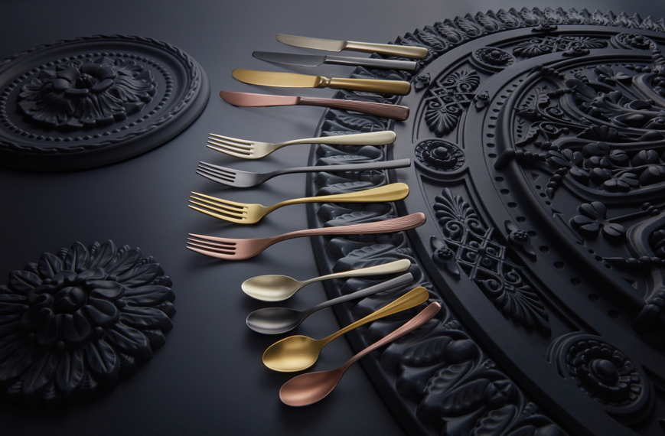
The TALIA and CARLTON cutlery collections by HEPP are now also always available with a finish from stock. With its distinctive length, TALIA's slender, graceful design is even more striking thanks to the copper PVD coating. The model looks completely different in anthracite, where the subtle Asian features are highlighted even more clearly. By contrast, the CARLTON cutlery series, with its sweeping line, is reminiscent of the classic, round shape of bygone eras. This is impressively emphasised by the gold PVD variant. The combination of gold PVD coating and brushed surface vividly expresses the fusion of modernity and tradition in the ACCENT range.

Finishes for an extravagant look
In the stone washing process, cutlery is treated mechanically using a mixture of grinding tools and a special solution to create truly unique pieces with distinctive character and an impressive vintage look. Treatment with glass beads, on the other hand, gives cutlery a velvety surface. Small glass spheres act on the cutlery at high speed and under great pressure. Since this technique strengthens and cleans at the same time, it also creates a particularly homogeneous surface. PVD coating gives cutlery collections an eye-catching tone with different colour shades. The wafer-thin yet very hard layer provides stylish accents in copper, gold, anthracite and light gold colours. All PVD-coated cutlery is dishwasher safe. The surface structure of the brushed cutlery is matt, and looks fine and velvety. To achieve this effect, each piece is treated with special bands, resulting in a dynamic curve that gives the cutlery an added dimension.

Image request
Images are available for downloading from our media portal http://press-n-relations.amid-pr.com. Simply by searching for the term „proheq-Oberflächen-2019“.

Further information:  proHeq GmbH  Carl-Benz-Str. 10 – 75217 Birkenfeld, Germany  Tel.: +49 7231 4885-0  Fax: +49 7231 4885-83  info@proheq.de – www.proheq.de | Press and public relations:  WMF Press Office  c/o Press’n’Relations GmbH  Monika Nyendick  Magirusstr. 33 – 89077 Ulm  Tel.: +49 731 962 87-30 – Fax: +49 731 962 87-97  mny@press-n-relations.de - www.press-n-relations.de

About proHeq
proHeq GmbH is a global premium supplier for restaurants, hotels, airlines and system catering. As a subsidiary of the WMF Group, it is one of the most important specialists in the field of professional hotel equipment. Both HEPP and WMF Professional come together under the umbrella of the proHeq company – both brands still operate independently on the market and therefore have different brand strategies and sales structures. On the other hand, the large retailer Boehringer Gastro Profi GmbH is part of proHeq GmbH. Since the end of 2016 proHeq GmbH has been part of the French conglomerate Groupe SEB.

