Refreshing Coffee Creations for Summer Enjoyment
Innovative machine features enable effortless preparation of cold coffee drinks – with or without alcohol

Zuchwil, 24 July 2025 – From classic Iced Cappuccinos to on-trend signature drinks like the Cinnamon Roll Latte – cold coffee beverages infused with syrups and more are enjoying growing popularity. According to the Allegra Project Café USA 2024 report, 79% of consumers under the age of 35 typically purchase an iced coffee beverage at least once a week. For those looking to add an extra caffeine kick to their evening out, coffee-based cocktails now feature prominently on many bar menus. These include classics like the Espresso Martini or trending drinks such as the Carajillo, which is currently experiencing a surge in popularity across various countries. Thanks to the innovative features of Schaerer Coffee machines, these drinks no longer need to be prepared manually from start to finish.

The advantages of automated preparation are clear: staff do not need to be trained baristas or bartenders, and can serve a wide range of beverages quickly and with consistently high quality. For operators, this opens the door to expanding their drinks offering and attracting new target groups – without the need for additional or specially trained staff. Schaerer recognised the trend for cold coffee specialties early on and was among the first to launch a feature for the fully automatic preparation of cold coffee beverages: the Hot & Cold technology for the Schaerer Coffee Soul. This innovation cools the freshly hot brewed espresso to 30-35 °C during dispensing, creating the perfect base for flavourful cold coffee compositions. The Schaerer Coffee Soul offers various setting options to flexibly customise the beverage range to individual requirements – including different bean blends, milk types and other ingredients. Once selected, the drink is dispensed with minimal effort from staff and in consistently high quality. Syrup, liqueur or spirit are added precisely via the Flavour Point syrup station, while the patented Best Foam milk system delivers cold milkfoam and milk (or plantbased milk) at the desired temperature and in the perfect consistency. Only a few final touches – such as decorating or shaking – are required before the refreshing coffee delight is ready to be served.

Just a few years ago considered niche, cold coffee drinks are now more in demand than ever. By expanding their beverage menus to include cold coffee specialties, operators can offer guests a unique taste experience and stand out from the competition. Schaerer presents a few recipe inspirations for the summer of 2025:

Cinnamon Roll Latte

A perfect blend of aromatic espresso and the sweet, comforting flavour of cinnamon rolls – served hot or iced.

Ingredients:
- 35 ml espresso
- 20 ml cinnamon roll syrup
- 110–170 ml cold milk
- 50–80 ml cold milk foam

Preparation:

Can be prepared manually or fully automatically with the Schaerer Coffee Soul (required features: Hot & Cold technology, Best Foam milk system, Flavour Point syrup station). Add ice cubes to a glass, followed by espresso, syrup and the desired amount of milk. Finish with a layer of silky milk foam.

Carajillo – Trending Coffee Cocktail

This vibrant cocktail combines espresso with Licor 43, a Spanish liqueur infused with 43 herbs and spices.

Ingredients:
- 25 ml espresso
- 20 ml Licor 43
- Ice cubes
- 1 organic orange

Preparation:

Shake chilled espresso, Licor 43 and ice cubes vigorously. Pour over fresh ice in a glass and garnish with a slice of orange. For an aromatic twist, add cardamom, arak or piloncillo (unrefined cane sugar).

Espresso Martini – The Modern Classic

An iconic cocktail that’s bold, smooth and elegant – perfect for after-dark enjoyment.

Ingredients:

50 ml vodka

35 ml coffee liqueur (recommended: Kahlúa)

25 ml cold espresso

Preparation:

Combine vodka, coffee liqueur and cold espresso. Shake over ice and serve in a pre-chilled glass – traditionally without milk foam. When using the Schaerer Coffee Soul, preparation is supported by the Hot & Cold technology. Vodka and coffee liqueur are dispensed via the Flavour Point syrup station.

Schaerer’s Power Trio for Cold Coffee Creations

At the heart of Schaerer’s Hot & Cold technology is a specially developed beverage cooling system that chills the coffee during dispensing – ideal for iced drinks. This ensures the ice melts more slowly, preserving flavour and preventing dilution. Beverages are prepared to a consistently high standard by simply selecting the corresponding recipe. The patented Best Foam milk system delivers milk foam of outstanding quality. Thanks to steam heating, the result is on par with manual barista steaming. The patented mixer processes virtually any type of milk or plant-based alternative into creamy foam with a silky sheen. Foam consistency – from liquid to firm – and temperature can be individually pre-set for each recipe.The Flavour Point syrup station holds up to four different syrups. The required dosage is also defined within the machine’s recipe system – enabling fully automated preparation of cold coffee drinks, even those with a kick of alcohol.

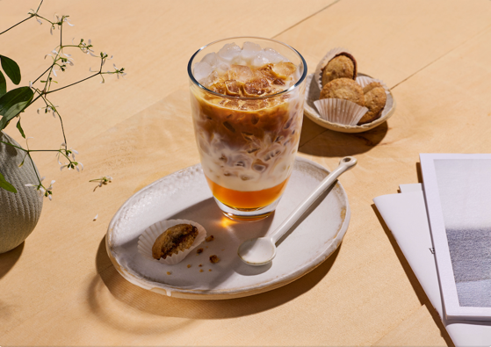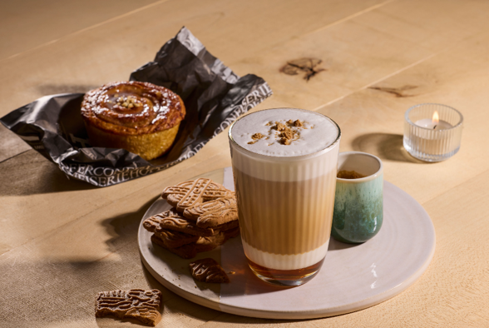

Images
You can find image material for download here

Further information:
Schaerer Ltd.
Monika Kammermann
Niedermattstrasse 3b, CH-4528 Zuchwil, Switzerland
Tel.: Tel. +41 32 681 62 00
info@schaerer.com
www.schaerer.com
https://aboutwmf.com/de/news-media/newsroom/schaerer/

Schaerer Press Office
c/o Press'n'Relations GmbH,
Nataša Forstner
Magirus-Deutz-Straße 14, D-89077 Ulm, Germany
Tel.: +49 731 146 156-77
nfo@press-n-relations.de
https://press-n-relations.com

About Schaerer
Founded in 1892 and headquartered in Zuchwil, Switzerland, Schaerer Ltd. is one of the world's leading manufacturers of fully automated professional coffee machines. As a well-established brand with a long history, Schaerer stands for Swiss values combined with in-depth knowledge on coffee. The brand emphasizes these attributes in its claim “swiss coffee competence” and lives them equally in its product development and the Coffee Competence Centre, Schaerer’s coffee competence and training centre in Zuchwil. Moreover, Schaerer is characterised by extreme flexibility adhering to the guiding principle of “We love it your way” - whether it concerns customer requests, customer-specific products bulk orders or the product range which offers the customer a wide collection of customised configuration options. Customer-oriented and equipped with comprehensive knowledge on coffee, Schaerer supports any customer of any size all over the world in offering guests delicious coffee of the highest quality. Schaerer has been part of the French consortium Groupe SEB since 2016.

About SEB Professional
As part of Groupe SEB, SEB Professional is a global leader in beverage equipment solutions, committed to delivering innovative products that meet the evolving needs of the foodservice industry. From coffee to fresh juice, our portfolio of brands (WMF, Schaerer, Curtis, La San Marco and Zummo) sets the standard for quality, performance, and sustainability. Since our inception, our mission has been to leverage the experience of consumers and professionals with cutting-edge technologies that make every cup and drink memorable.

