Bonn, 14 May 2019
transport logistic, June 4-7 2019, Munich Trade Fair Centre /
Hall A3, Booth 622
No matter what, where, when, and how: All transports under control
ORBCOMM presents innovations for truck, driver and tachograph management, HACCP-compliant temperature recorders and new all-in-one cargo sensors and tracking systems
At this year's transport logistic, the leading international provider of industrial IoT solutions will be presenting numerous innovations in its fleet management solutions for transport and logistics. Fleet managers thus receive a real-time view as well as reliable control options over trucks, coaches and buses, refrigerated and dry trailers and intermodal containers – independent of load, location, time and mode of transport. The trade fair highlights range from comprehensive vehicle management including cold chain security to reliable and economical trailer and container tracking solutions to specific telematics applications for trucks, trailers and buses.
Comprehensive and flexible - truck management by ORBCOMM
As currently the most comprehensive truck management solution on the market, the open and scalable ORBCOMM telematics platform combines driver-oriented cabin devices based on Android with the globally proven ORBCOMM tracking hardware BT 500 and the powerful backend reporting of the FleetManager software. Fleet operators can thus not only comply with individual tachograph rules, but also with country-specific labour laws. With a wide range of applications, companies can improve driver performance and fleet safety as well as employee productivity and operational efficiency. A wide range of functions are available for this purpose, including real-time speedometer data, automated downloads, driving violation evaluations, driver performance evaluation, safety reports/analyses, vehicle-specific navigation, order scheduling, document scanning, real-time location, fuel management and maintenance manager.
Cool from A to Z - Safe cold chain compliance with Euroscan X3 and MX2
The Euroscan X3 temperature recorder and the HACCP-compliant Euroscan MX2 communication module provide companies with a solution for ensuring their cold chain compliance. The devices provide reliable monitoring of transport refrigeration and cold chain maintenance. Both units are GAMP 5 certified and the MX2 also meets HACCP (Hazard Analysis and Critical Control Points) requirements. As part of ORBCOMM's cold chain compliance solutions, they can be used on a variety of means of transport and score points in harsh road, rail and sea environments.
Powerful and Solar Powered - Trailer and Container Tracking Solution ORBCOMM GT 1200 series
The new ORBCOMM GT 1200 series of solar-powered devices for trailers and containers offers multiple sensor options, user-friendly applications, reliable mobile communications and optional satellite connectivity. The integrated solar module can be charged very quickly even without direct sunlight – an advantage when used on cloudy days and in northern latitudes. With the new design, the devices can be installed vertically and horizontally on all system types and quickly put into operation.
Flexible control of refrigerated containers by land, rail and sea:
ORBCOMM CT 3000 series
With the new CT 3000 series tracking solution, forwarders and ports now have a flexible and economical way to monitor third-party containers both continuously and route-based. For valid data such as location, status, performance and freight cargo hold temperature, they support built-in and external sensors as well as mobile communications and wireless technologies. The new series is available in two versions: The CT 3000 is permanently installed, while the CT 3100 is temporarily mounted via magnets. This allows not only continuous, but also time-limited tracking and control of the moving goods in an economical way - completely independent of the traffic routes. The result: with the reusable asset tracking solution CT 3100, high-value freight or third-party systems for which permanent device installation is not possible can now be monitored depending on the tour.
Telematics solutions for buses
Bus and travel companies are particularly interested in the latest developments in ORBCOMM's bus management solution based on the BT 500 and FleetManager platform. In view of the growing market for international long-distance bus services and the relevant legal requirements, the ORBCOMM application not only makes it easier than ever to comply with the relevant regulations for tachographs and increase driving safety, but also optimises the performance of drivers. Especially against the background of stricter driving and rest time controls, suitable driving shifts can be planned easily and quickly in this way, taking into account the prescribed breaks. In this way, infringements can be contained and fatigue-related accidents avoided. The tachograph regulation, known as the "twelve-day rule", is also taken into account in real time. It stipulates that bus drivers can work for up to twelve consecutive days on a single international bus trip, provided they follow specific rest periods before, during and after the trip. The bottom line for companies is improved employee productivity and operational efficiency.
Real-time asset tracking and monitoring even under
harsh conditions: GT 1020
The GT 1020 is a compact, rugged and energy-efficient all-in-one telematics device designed specifically for tracking applications in mining, construction and other demanding environments. It withstands extreme weather and environmental conditions such as dust, water, shock and vibration. This ensures uninterrupted connections and constant operation. Equipped with integrated mobile phone and GPS antennas, it is not only quick and easy to install, it can also be precisely located via the LTE mobile phone network with 3G/2G fallback protection. This reduces cost-intensive downtimes and makes it easier to find suitable trailer frames for follow-up orders. Thanks to its small size, it can also be discreetly installed on smaller vehicles and equipment to prevent theft and manipulation. The permanently installed rechargeable battery, which allows reporting for up to nine months without an external power supply depending on the reporting frequency, helps in this respect. As a turnkey solution, the device is available with ORBCOMM's FleetEdge Management Portal. APIs and integration tools are also available to facilitate integration with proprietary or third-party applications.

Pictures

ORB_BT500-ShineFix.jpg
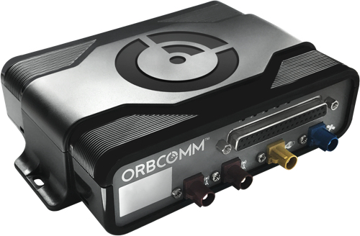
The BT 500 truck tracking system offers complete transparency, monitoring and management of drivers, vehicles and displays. (Photo: ORBCOMM)
ORB_FM_DACH_WorkingHours.jpg
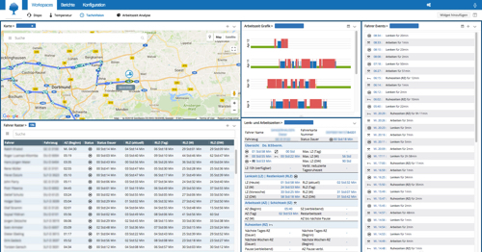
ORBCOMM truck management solution records driving, working and rest times – seamlessly, in detail and precisely. (Photo: ORBCOMM)

ORB_X3_02.jpg, ORB_MX2_01.jpg
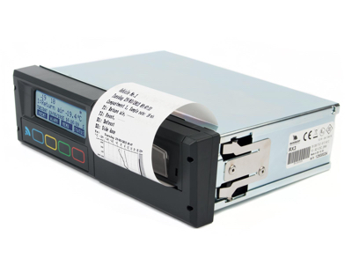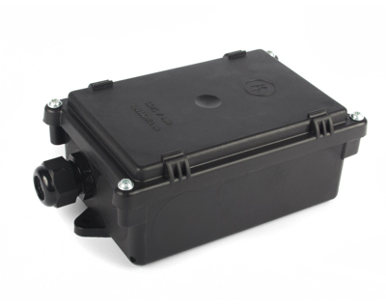
Complete cold chain monitoring with ORBCOMM: Euroscan X3 temperature recorder (left) and reliable
two-way temperature monitoring with Euroscan MX2 (right). (Photos: ORBCOMM)

ORB_CT-3000.jpg, ORB_Cargocontainers.jpg
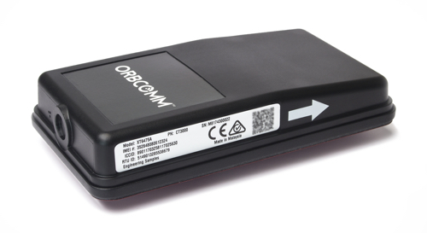
Flexible and easy to install: The CT 3000 series allow seamless remote monitoring and control of refrigerated containers for land, rail and sea transport – whether continuous or temporary. (Photos: ORBCOMM)

ORB_GT1200_01.jpg
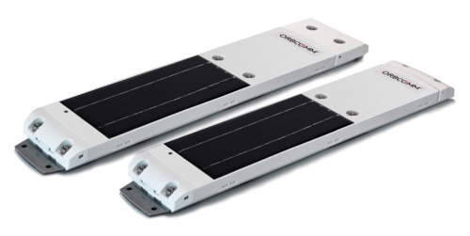
Can also be used in harsh environments: the new solar-powered asset tracking device series GT 1200 series. (Photo: ORBCOMM)
ORB_GT_1020_Black.jpg
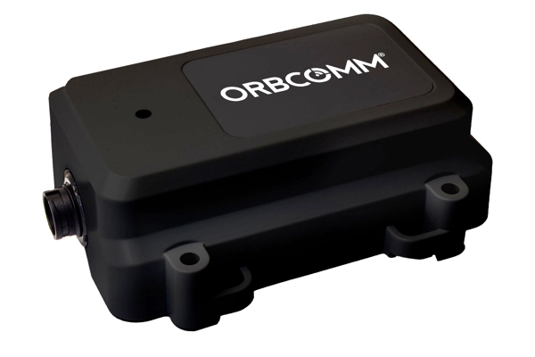
Optimally suited for rough use on heavy equipment in the construction and mining industries: ORBCOMM GT 1020. (Photo: ORBCOMM)

Further informations:  ORBCOMM Inc., Sue Rutherford  Ontario, CANADA  phone: +1 613.254.5269  rutherford.sue@orbcomm.com  www.orbcomm.com | Press and Public Relations:  Press’n’Relations GmbH, Uwe Taeger  Magirusstraße 33, 89077 Ulm, Germany  phone.: +49 731 96 287-31  fax: +49 731 96 287-97  ut@press-n-relations.de  www.press-n-relations.de

ORBCOMM inc.
ORBCOMM (Nasdaq: ORBC) is a global leader and innovator in the industrial Internet of Things, providing solutions that connect businesses to their assets to deliver increased visibility and operational efficiency. The company offers a broad set of asset monitoring and control solutions, including seamless satellite and cellular connectivity, unique hardware and powerful applications, all backed by end-to-end customer support, from installation to deployment to customer care. ORBCOMM has a diverse customer base including premier OEMs, solutions customers and channel partners spanning transportation, supply chain, warehousing and inventory, heavy equipment, maritime, natural resources, and government. For more information, visit www.orbcomm.com.

