Memmingen, April 25, 2019
Impressive presence at Bauma
Keen response to world firsts by Goldhofer
Enormous increase in visitor totals plus numerous promising talks and contracts signed
Goldhofer Aktiengesellschaft was very satisfied with the outcome of Bauma 2019. The great interest shown by trade visitors in the new products and features making their public debut and the high level of demand for quality transport solutions more than exceeded the expectations of Rainer Auerbacher, Member of the Board Transport Technology at Goldhofer Aktiengesellschaft. A particularly pleasing development was the high increase in the number of trade visitors from abroad. A major source of interest was the world premiere of Goldhofer’s new innovative electronic steering system, the new tire with low diameter and high tire load and an extremely resilient floor covering. The crowds were also drawn by the PST with »SPEEDRIVE« function and the »ADDRIVE 2.0« heavy-duty module that can be used in both the self-propelled and the towed modes. Rainer Auerbacher's conclusion: „Bauma is simply the Mecca of the construction and transport industry.“
The new features incorporated in Goldhofer’s Bauma innovation vehicle are always top secret and are not revealed until the first day of the event. Once again the excitement was correspondingly great, as evidenced by the many media representatives attending the premiere.
Visitors were also highly impressed by the study for an electronic steering system featured on the STZ-L 4. The system guarantees the optimum steering angle in every situation, taking full account of the weight, dimensions, position and length of the load. The result is a steering performance that ensures maximum maneuverability of the low-loader. For optimum maneuvering, the system offers a choice between individual steering modes, with a radio remote available for operation from the driver’s cab.
The deck of this year’s innovation vehicle featured Goldhofer’s new hard-wearing polymer covering, which offers outstanding resistance to environmental influences such as UV light as well as cargo-related damage. With an ideal coefficient of friction for load securing that is better than rubber matting, the new covering is much thinner and lighter, thus reducing deadweight by up to 500 kg per vehicle.
A further feature included the »CARGO PLUS« low-profile tire developed especially for Goldhofer, which reduces loading height by up to 80 millimeters. These allow shorter vehicle solutions due to their higher permitted load capacity and thus make transporters more efficient.
There was equally keen interest in the other solutions presented at Bauma such as the »ARCUS« PK and Goldhofer’s intelligent solution for transporting wind turbine blades »VENTUM« in combination with »BLADEX« and the FTV 500. The PST with the »SPEEDRIVE« freewheel function and the new »ADDRIVE« 2.0 were also real crowd-pullers, as the many questions and animated discussions showed.
Goldhofer will be attending the next Bauma in three years’ time. Rainer Auerbacher says: „As the leading trade show for the industry, Bauma offers Goldhofer an ideal opportunity to meet with proven experts from the field of construction and to debate new transport solutions. The discussions held there stimulate thinking on both sides and generate interesting approaches to innovative solutions. Maybe we will be presenting the results at Bauma 2022!“

(GOL_bauma2019_B.jpg, GOL_bauma2019_D.jpg, GOL_bauma2019_A.jpg)
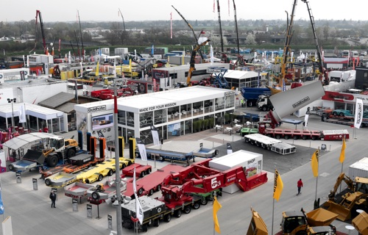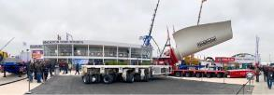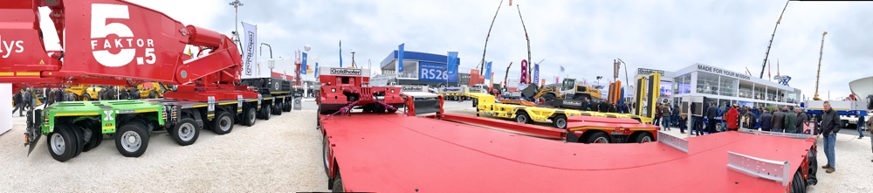
Goldhofer at Bauma 2019. (photos: Goldhofer)

(GOL_bauma2019_C.jpg)
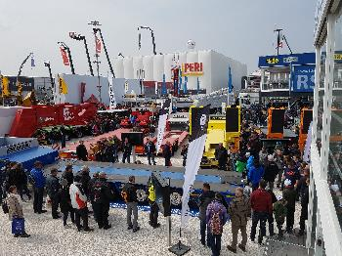
Goldhofer’s Bauma innovation vehicle pulled the crowds. (photo: Goldhofer)
(GOL_Rainer_Auerbacher.jpg)
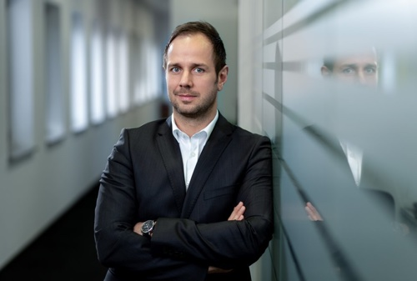
Rainer Auerbacher, Member of the Board Transport Technology at Goldhofer (photo: GOLDHOFER)

Further information:  GOLDHOFER Aktiengesellschaft, Erich Traub  Donaustrasse 95, 87700 Memmingen  phone.: +49 8331 15-225  fax: +49 8331 15 70 225  erich.traub@goldhofer.com  www.goldhofer.com | Press relations and PR:  Press’n’Relations GmbH, Uwe Taeger  Magirusstraße 33, D-89077 Ulm  phone.: +49 731 96 287-31  fax: +49 731 96 287-97  ut@press-n-relations.de  www.press-n-relations.de
Goldhofer-Unternehmensgruppe
The Goldhofer Group has about 800 employees designing and producing practical heavy haul and special transport solutions for the most challenging logistics requirements. The beginnings of the company with its twin locations in Memmingen and Ostfildern, Germany go all the way back to 1705.
The Transport Technology division delivers user-oriented heavy-haulage solutions and a full range of dedicated accessories for on- and off-road operations with payloads of up to 15,000 tons and more, plus regional modifications in line with the local infrastructure and market requirements. In addition to trailers and semi-trailers for the construction and haulage industries, Goldhofer also supplies transport systems for the wind power industry and a range of heavy-duty combinations with and without hydrostatic drive for transporting oversized and heavy cargos.
The Airport Technology division has a focus on the specific requirements of airport logistics. The division’s wide range of conventional and towbarless aircraft tow tractors, aircraft recovery systems, and cargo and baggage tractors in all size classes are reliable performers for continuous operations in ground support at airports worldwide. With its transport solutions in zero-emission e-versions (»IonMaster« technology), Goldhofer is also a prominent pioneer in the field of e-mobility.

