Darmstadt, August 22, 2017
Clean air in underground mines
AKASOL supplies lithium-ion battery systems to
Canadian mining equipment provider MEDATECH
Based in Collingwood (Ontario), Medatech Ltd., the Canadian provider of sustainable drive systems for the mining industry, now incorporates AKASOL GmbH’s AKASystem AKM NANO lithium-ion battery systems into its designs for electrically powered equipment and drives. Medatech will equip everything from drilling and anchoring machines to heavy transport vehicles with the systems in order to meet the extremely high performance requirements that apply to opencast and underground mines.
In addition to noise and heat, the use of combustion engines in underground mines produces a great deal of exhaust fumes. The use of electrically powered drilling machines and vehicles can significantly reduce health risks and the high costs of the protective measures required to mitigate them. The experts at mining equipment provider Medatch are responsible for ensuring that the high performance values required of these machines are reached – even under harsh working conditions. The company is now equipping its electrically operated excavation machinery and mining vehicles with high-performance battery systems made in Germany. Medatech had strict criteria when it came to selecting the right high-performance batteries for use in the mining industry. “We were looking for a liquid-cooled battery with in-built temperature management that would work consistently and reliably in a robust and safe housing. We also wanted to see evidence of practical experience and operating data. The same underlying standard applied to all criteria: safety before price. After much discussion and extensive testing, AKASOL was the only company from the pool of candidate providers that met our requirements, while scoring top marks in the process,” states David F. Lyon, Business Development Manager and Mechanical Engineer at Medatech. Having more than 25 years of experience in the automotive industry and a broad customer base in the commercial vehicles sector was also a plus factor for the Darmstadt-based high-performance battery manufacturer. The batteries produced in Darmstadt are now used to provide the anchoring machine produced by mining equipment manufacturer MacLean (Collingwood/Canada) with the power it requires. Thanks to the mining equipment supplier’s machinery, construction could get underway on the first gold mine in Canada (Goldcorp Inc.) to exclusively use electrically operated machinery at the end of 2016.
AKASYSTEM AKM NANO technical data
The drilling and anchoring machine produced by MacLean is fitted with the AKASOL liquid-cooled battery system, which has a storage capacity of 30.6 kWh at a nominal voltage level of 666 V, enabling it to reach 77 kW on average (peak: 406 kW/10 s). It is fully operational at ambient temperatures of between -25°C and 45°C and comes equipped with an intrinsically safe overload and overvoltage element. The AKASOL battery system also allows emergency operation features to be implemented. AKASystem meets the highest safety standards and protection provisions set out in USABC, IEC, SAE, UN 38.3 and IP 6K9K (IEC 61508 and EN 12663; modular subsystems are checked in accordance with EN 61373, EN 50121, EN 60529 and UN 38.3).
AKASYSTEM
The AKASYSTEM lithium-ion battery systems are some of the world’s most efficient battery solutions for vehicles with hybrid and electric drives. Fully scalable and based on a modular design, they individually adapt to the energy requirements of the vehicle and area of application in question. Highly-integrated AKAMODULE modules serve as the basis, enabling an energy density of more than 140 kWh/kg to be achieved and giving the vehicle an extensive operating range. The AKASYSTEM line’s design is aligned with the vehicle production process. All connections are prepared for large-scale production, making integration simple and keeping the effort required to a minimum. The novel design of the efficient water-glycol liquid-cooling system makes the AKAMODULE extremely compact. The modules are combined with the cooling system within an extremely robust housing to create a compact, lightweight unit that packs a real punch. The optimized, active thermal management element enables a consistent temperature level to be achieved even under high stress, and significantly extends the service life.
Diesel-free underground mining pays off
Emissions in underground mining are a challenge both with regard to health and in economic terms. The majority of diesel-powered drilling, anchoring and transport machines produce exhaust gases that have to be siphoned off by large ventilation units via shafts established specifically for that purpose. This is both laborious and cost-intensive. One solution is to rely on high-performance, electrically powered machines, which source their electrical energy from trailing cables or high-performance batteries. Battery-powered machines are increasingly being used for more flexible applications, e.g. due to their maneuverability.

Images
MDT_RoofBolter_MacLean.jpg, MDT_BoomTruck_MacLean.jpg
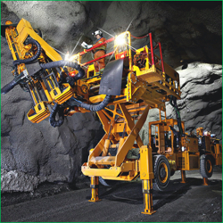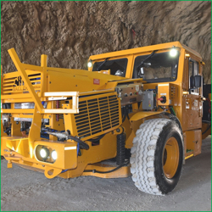
Clean and economical: The use of electrically powered vehicles and equipment in the mining industry reduces costs considerably. (Photos: Medatech)
MDT_RoofBolter_Battery.jpg
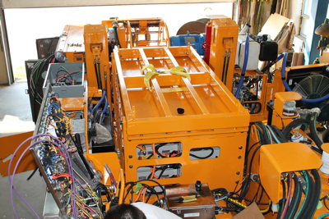
Stable and safe storage for underground use in harsh conditions: the AKASOL AKASYSTEM 15 AKM NMC NANO lithium-ion battery system. (Photo: Medatech)

Further information  AKASOL GmbH, Katja Steinhauser  Landwehrstraße 55, 64293 Darmstadt, Germany  phone.: +49 6151 80 05 00-140  fax: +49 6151 80 08 00-129  katja.steinhauser@akasol.com  www.akasol.com | Press and public relations:  Press’n’Relations GmbH, Uwe Taeger  Magirusstraße 33, 89077 Ulm, Germany  phone.: +49 731 96 287-31  fax: +49 731 96 287-97  ut@press-n-relations.de  www.press-n-relations.de
About AKASOL
AKASOL GmbH has developed and manufactured mobile and stationary high-performance battery systems for the German and European market for 25 years. Its multi-award-winning storage solutions are used primarily in the automotive and commercial vehicle industries, the off-highway industry, and the solar power and wind power sectors.

